2016 –7 4K TVs, Black and Gray Interior, 32 Foot Gooseneck with 7000kw Generator and Central Heat/Air
Mobile Video Game Theater: $89,000
Mobile Video Game Theater and Truck: $98,000
Tons of custom upgrades and ready to be picked up today! 2007 Ford F350 4x4 wrapped to match is included. This 36-foot Gooseneck Video Game Theater includes a Black and Gray Interior, Library of 65 Video Games, Vertical Vinyl Shades at Doorway, Exterior Awning, Three Outside Gaming Stations with 75” TVs, Satellite Ready, Movie Night Ready and 3D Options. Interior boasts Five 55" TVs, Two Racing Seats and Racing Wheel/Pedal Simulator, Surround Sound, Laser and Mood Lighting, Blu-Ray DVD player w/ Bluetooth for music, custom limousine seating, 6 Ft. Tables & Chairs for rentals and 12 Staff Shirts and 10 hats included. Power supplied by a Cummins/Onan 7000 kw commercial generator with a 60-gallon gas tank. Gaming Systems include 7 X Box Ones, 6 WII Us and Remotes.

Truck/Tow Vehicle
2007 Ford F350 4x4

Mobile Video Game Theater
Make: Continental
Year: 2016
Asking Price: Mobile Video Game Theater - $89,000
Asking Price: Mobile Video Game Theater and Truck - $98,000
MSRP: $150,000
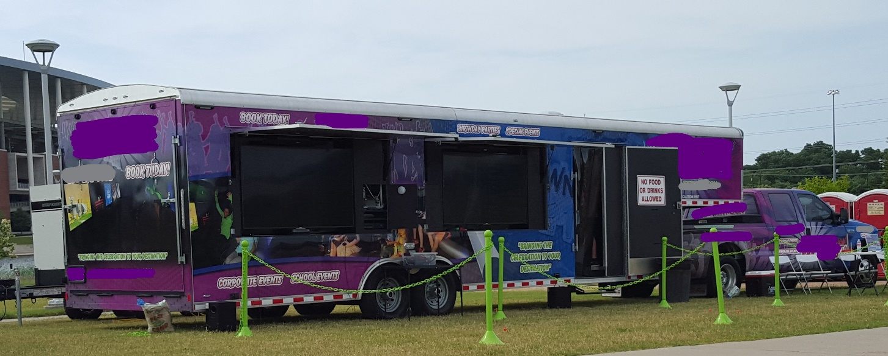
Maintenance
Generator: Last Maintenance - June 2017
Age of tires: 1 year – great condition
Number of TV's/Gaming Stations Inside: 5
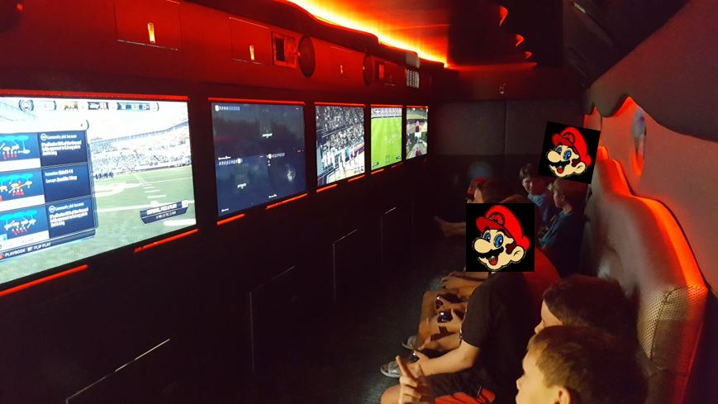
Number of TV's/Gaming Stations Outside: 2
Game Consoles: 7 X Box Ones, 6 WII Us and Remotes
Approximate number of games included: 40

Mobile Video Game Theater
32 Foot Gooseneck 7000kw Generator and Central Heat/Air
60 Gallon Fuel Tank installed
Interior Colors: Black and Gray
Custom Upgrades Included
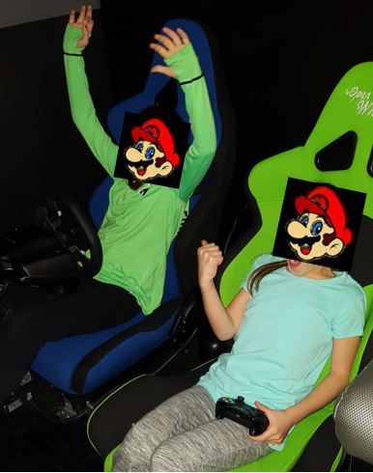
Vertical Vinyl Shades at Doorway
Exterior Awning
Two Outside Gaming Stations with 75” TVs
Satellite Ready
Movie Night Ready
3D Options
Two Racing Seats and Racing Wheel/Pedal Simulator
Surround Sound
Laser and Mood Lighting

Blu-Ray DVD player w/ Bluetooth for music, custom limousine seating
Spare Tire
5 - Samsung 55" High Definition TVs with Speaker Bars
2 - Samsung 75" High Definition TVs with Speaker Bars

Two minor scratches on outside of trailer and the top left-hand side of the trailer has minor damage

